Chapter 11, Problem 6.

For the circuit in Fig. 11.38, 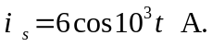 Find the average power absorbed by the 50-Ω resistor.
20i_{x}

+ –

i_{x}

50 Ω 20 mH
i_{s}

40 F
10 Ω

Figure 11.38
For Prob. 11.6.

